- Suppose that a data warehouse consists of the three dimensions Dime, doctor, and patient, and the two measures count and charge, where charge is the fee that a doctor charges a patient for a visit.
- Design a star schema for such a data warehouse.
- Identifying the fact table(s) and dimension table(s).
- Identifying their primary key(s), foreign key(s) and measures.

- Suppose that a data warehouse consists of the four dimensions, date, spectator, location, and game, and the two measures, count and charge, where charge is the fare that a spectator pays when watching a game on a given date. Spectators may be students, adults, or seniors, with each category having its own charge rate.
- Design a star schema for such a data warehouse.
- Identifying the fact table(s) and dimension table(s).
- Identifying their primary key(s), foreign key(s) and measures.

- Convert 3NF to Dimensional modeling
- Design a star or snowflake schema for such a data warehouse.
- Identifying the fact table(s) and dimension table(s).
- Identifying their primary key(s), foreign key(s) and measures.

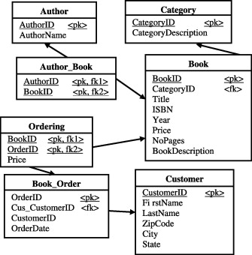

- Convert 3NF to Dimensional modeling
- Design a star or snowflake schema for such a data warehouse.
- Identifying the fact table(s) and dimension table(s).
- Identifying their primary key(s), foreign key(s) and measures.

